Bra ket, also called dirac notation is convenient notation used, to represent Qubit state,

**Example:** 1/sqrt2 * a*|0> b*|1> ; plane for real a,b on blackboard, add that a,b could be complex, so we couldn’t show every state on simple plane. For this purpose there is bloh sphere.

outer product

indukcja normy przez iloczyn,

qbit state/ base vector, measurement probability / bloch sphere/superpozycja entanglement state

Photon linear and circular polarization referred as elliptical polarization.

Gates:

NOT

Controled rotation gate.

Hadamard gate

preservationn inner product, reversible

The matrices looks quiet easy, but of course not every simple matrix could be implemented as quantum gate. It should preserve norm, it is just a simple quantum rule Unitary matrices meet the requirement.

Here is definition: U is an unitary matrix if: UU* = U*U = I. I will explain it. conjugate identity.

It could be proved that linear transformation U full fill norm preservation requirement.

**example:** two unitary transform is also unitary transform - H*(CRG*(CRG(H))

I would forget - norm is the same as probability. We will use it. So example.

**example: |000>**

There is also another worth to mention rule, it is no cloning theorem, which states that it is impossible to create an identical copy of an arbitrary unknown [quantum state](https://en.wikipedia.org/wiki/Quantum_state).

Uncomputing…?

Grover search:

Grover diffusion operator. 2 |s><s| - I |s><s| is outer product

Uw operator, simple proof:

<https://en.wikipedia.org/wiki/Grover%27s_algorithm#Description_of_U.CF.89>

fig 2.15

Inversion about the mean – quantum computing devices Goong - p. 68 fig 2.16 prawdopodobienstwo 1 dla 2 qitów?, zlozonosc O(1) ??

Liczba iteracji > sqrt(N) nie zwieksza precyzji, lecz zmniejsza.

Shor:

Grupa z względnie pierwszych z N z mod(N), rząd grupy, może jakiś dowód

Multiplicative group of integers modulo n

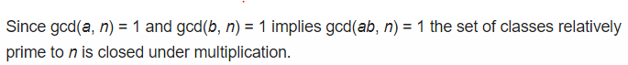

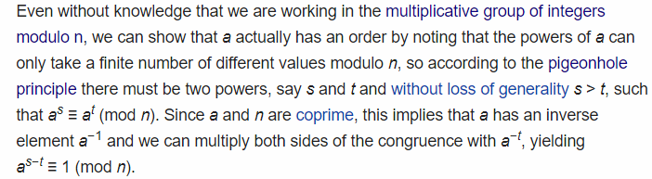

qft: continued fraction , dlaczego nie maksymalna wartość?